Elena Weissmann

Visualizing Vision

April 12, 2018

Lab Report: Specularity and scene in the perception of shape

**Abstract:** Everyday, we observe objects with varying levels of specularity, such as puddles of water, plastic bottles, and computer monitors. Intuitively, we perceive that this specularity can aid 3D shape estimation: the light reflecting off a teapot, for example, provides us with information about its curvature. Previous studies have supported this idea (J.F. Norman, J.T. Todd, & G.A. Orban, 2004; Todd, Norman, Koenderink, & Kapers, 1997), though few have elaborated on the mechanism through which it occurs. Fleming, Torralba, and Adelson (2004) suggest that surface curvatures of specular objects cause image compressions that are diagnostic of 3D shape, even when the image reflected in the object is changed. In order to explore this idea, I investigate whether specular reflections alone provide enough information to perceive three-dimensional shape, and also how perception changes across different levels of specularity and different image reflections. I show that people can reliably perceive 3D shape of specular objects presented in static images, even though these images contain no motion, stereo, or shading. I also find that, in a discrimination task, subjects are more accurate at perceiving 3D shape for slightly specular objects than for perfectly specular objects, though scene reflected in the object has no effect on accuracy.

**Results:**

*Background*

In 2004, Fleming, Torralba, and Adelson published a paper in *Journal of Vision* that set out to explore the mechanisms underlying 3D perception of objects from specularity.. It had been well-established by previous studies that specular reflections assisted shape estimation, but it was not yet clear how that occurred (J.F. Norman, J.T. Todd, & G.A. Orban, 2004; Todd, Norman, Koenderink, & Kapers, 1997).

In the past, researchers had speculated that the visual system could recognize the environment by its distorted version reflected in the object, and that it then computed the “deforming transformation” that was applied to the reflected scene by the curvature of the object’s surface. Having done that, the visual system could, theoretically, estimate the 3D shape of the surface causing the distortion. Fleming et al. were not satisfied with this theory and put forth a new hypothesis: the visual system treats specularities somewhat like textures. Rather than reconstructing the scene reflected on the object based on its distortions, humans treat the reflection as a “texture” and gauge 3D shape based on how this texture is distorted. At the heart of this hypothesis is the fact that curved surfaces reflect more or less of the world, depending on its curvature. A highly curved surface “sees” more of the world, causing it to compress the scene more than a slightly curved surface. Thus, the degree of compression in an object’s reflection gives us important information about the curvature of the object.

Fleming et al. tested this idea by using filters to study the orientation fields of specular surfaces rendered under a range of scenes. They found that orientation fields provide accurate estimates of 3D curvature, with these estimates remaining stable across changes in reflected scene. In this paper, I seek to contribute evidence to their hypothesis by using human subjects to gauge 3D shape, rather than orientation filters. I investigate whether specular reflections alone provide enough information to discriminate between pairs of two very similar shapes, and how accuracy on this task changes across levels of specularity and varying scene reflections.

My paper is unique from Fleming et al.’s in two important ways: 1) I use human subjects, rather than orientation filters and 2) I investigate the effect of varying levels of specularity, whereas Fleming et al. only look into the effect of perfectly specular and opaque objects on 3D perception. For this experiment, subjects completed a timed discrimination task in which they determined whether two images, presented side-by-side, depicted objects with same or different shapes. Objects differed in three possible ways: material, reflected scene, and shape. There were two levels of material (perfectly specular and slightly specular), three scenes (a mountain scene, desert scene, and rock scene), and three shapes, with all objects set against a black backdrop. This created a total of 18 images, and every possible combination of images was presented to the subject during the

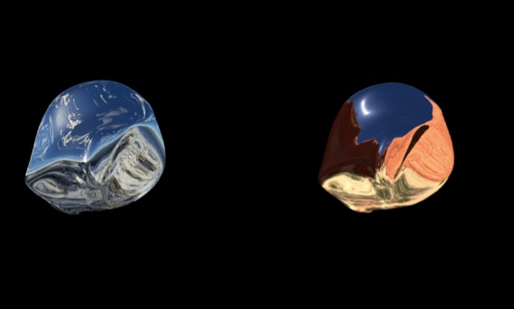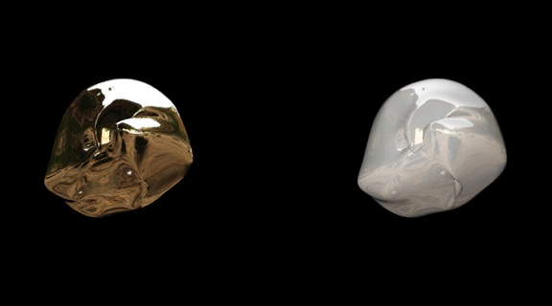experiment (Figure 1).

**Figure 1:** Two pairs of stimuli presented during the experiment. In the top pair, a subject is presented with two objects depicting the same shape and scene, but varying in specularity. In the bottom pair, a subject is presented with two objects depicting the same shape and specularity, but varying in scene. To obtain a correct answer for both, the subject must respond that objects are the same shape.

*Findings*

Using MATLAB R2018A, I calculated overall mean accuracy and reaction times per subject, as well as mean accuracy by material and scene. Overall accuracy was surprisingly high across all subjects, with an average of 91.9 percent. This data was plotted into a bar graph (Figure 2).

A two-way repeated-measures ANOVA was conducted on the influence of two independent variables (material, scene) on the mean accuracy of subjects. Material type included three levels (both objects perfectly specular, both objects slightly specular, and mixed) and scene type included two levels (same and different reflected scenes). The only effect found to be statistically significant was material (F = 5.29, p < 0.05), hence I conclude that material affected 3D shape estimation. I also found an interaction of material and scene that trended towards significance (F = 2.93, p = 0.078).

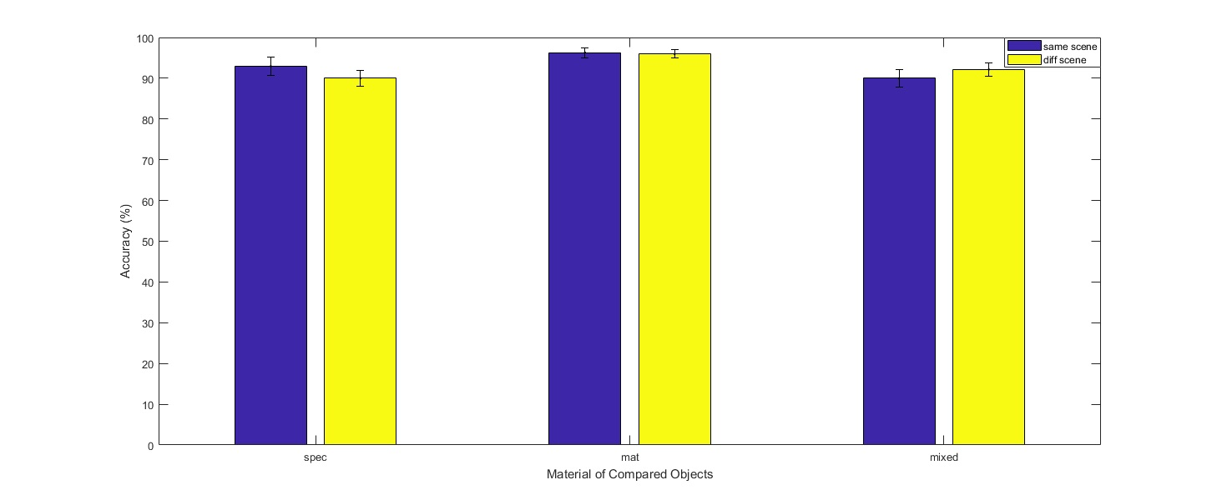In order to determine what was driving the effect of material on accuracy, I conducted paired samples t-tests between pairs of material types and found a significant difference between accuracy scores for slightly specular and perfectly specular materials (t(9) = -2.83, p<0.05) and between slightly specular and mixed materials (t(9) = 2.92, p<0.05). The difference between accuracy scores for perfectly specular and mixed was not significant. Overall, the ANOVA and t-tests reveal that the slightly specular material yielded significantly higher accuracy scores than both perfectly specular and mixed materials, a finding that can be visually scene in figure 2.

**Figure 2:** Bar graph of mean accuracy per subject across two independent variables, material and scene. ***Spec refers to “perfectly specular” and mat refers to “slightly specular”.

Figure 2 also shows variation in the effect of scene by material. For perfectly specular objects, for example, it appears that accuracy decreases when different scenes are reflected on objects, as opposed to the same scene. For mixed objects, it appears that accuracy increases when different scenes are reflected on objects. In order to investigate this possibility, I conducted paired samples t-tests on the effect of scene between pairs of material types and found a nearly significant difference in the effect of scene in the perfectly specular condition and the effect of scene in the mixed condition (t(9) = 2.23, p = 0.0522). There was also a nearly significant difference in the effect of scene in the slightly specular condition and the effect of scene in the mixed condition (t(9) = 2.09, p = 0.06). Both of these results explain the nearly significant interaction between material and scene observed in the ANOVA as well as the bar graph.

Finally, to test whether the independent variables of material and scene accounted for changes in reaction time, I fit two linear regression models for each variable. The models showed that neither variables had significant effects on reaction times.

**Discussion:**

*Interpretation of Results*

Through a two-way ANOVA and post-hoc tests, I found that subjects were more accurate in discriminating between two objects when both objects were slightly specular, versus when both objects were perfectly specular or when one object was perfectly specular and one object was slightly specular (mixed condition). This is likely due to the fact that the slightly specular objects contain shadows and highlights, therefore assisting in 3D shape perception and allowing for an easy comparison between objects, whereas perfectly specular objects contain neither. I did not find that subjects were more accurate when objects were mixed versus when they were both perfectly specular. It’s difficult to speculate as to why, though it’s possible that the mixed condition both assisted object comparison (by including at least one slightly specular object, with its shadows and highlights) and made it more difficult (by including two objects that differ in material), thus averaging out to a similar level of difficulty as the perfectly specular condition.

I also found that subjects’ accuracy was not significantly affected by scene: subjects performed similarly across trials in which the reflected scene was the same for both objects (e.g. both objects reflected the mountain scene) and the reflected scene was different (e.g. one object reflected the mountain scene, and the other object reflected the desert scene). This is similar to the results reported by Fleming et al., who find that 3D shape estimates remain stable when the world reflected in the surface is changed. As Fleming et al. hypothesize, this may be due to the mechanism through which our visual system gathers information on shape from a specular object: rather than rely on the specific scene’s reflection to perceive shape, the visual system instead treats specular reflections as textures warped onto the surface of the object, thus rendering our ability to perceive shape from specular objects regardless of what is reflected. My findings corroborate this hypothesis.

Finally, I found that reaction times were not significantly affected by material and scene. This was surprising, as I hypothesized that subjects would take longer with perfectly specular objects than with slightly specular objects. This finding may be due to the high average accuracy rates of subjects as well as the high number of trials. The high accuracy rates suggest that subjects found the task relatively easy, potentially causing them to speed through the trials regardless of material and scene. The high number of trials may have also tired out subjects, leading them to make split-second decisions, based on first-impression, rather than more thoroughly examining each image for each trial. In order to test this, it may be useful in future experiments to examine reaction time during the first 50-100 trials alone.

*Future Experiments*

It might be worthwhile to make this experiment more difficult in order to more accurately assess differences in accuracy across conditions. Subjects were given two seconds to view the images before image disappeared, and there were only three shapes presented across 324 trials. A future experiment could shorten viewing time to only one second or half a second, and additionally increase the number of possible shapes for the objects to take on. A future experiment might also include scenes that are more meaningful to the question being studied. Here, I chose scenes for no particular reason, while future experiment could include scenes that vary in brightness, for example, or vary in definition. This would allow us to determine whether certain aspects of a scene affect 3D shape perception, as opposed to just examining whether the sameness or difference in scenes for two specular objects affect discrimination.

**Methods:**

*Participants*

Participants in this study included 10 Brown University students, one of whom was an author of this work. Participants included 3 males and 6 females between the ages of 18 and 24. All participants in this study were volunteers. Most students were recruited out of the Visualizing Vision Course taught by Professor Fulvio Domini.

*Stimuli*

Stimuli consisted of single static images. Each image presented a shiny object set against a black backdrop, and the objects varied in 3D shape, reflected scene, and levels of specularity. There were three possible 3D shapes, three scenes (downloaded from [www.terragen3.com](http://www.terragen3.com)), and two levels of specularity: perfectly specular and slightly specular. Each image presented a combination of these three variables, creating a total of 18 images. One image, for example, could contain a perfectly specular shape with a snow scene reflected on its surface, while another image could contain a slightly specular shape with a desert scene reflected on its surface. A black background was included behind each object in order to ensure visual cues from the scene surrounding the stimuli would not affect shape perception. All of the images were rendered at a resolution of 1290 x 1080 pixels.

*Design and Procedure*

In this experiment, participants were asked to judge whether two stimuli, presented side-by-side and varying in shape, scene, and specularity, were identical in shape. Participants were seated on a height-adjustable chair so that their eyes were 60 cm from the surface of a 27-inch LED monitor. The directions for the task: click the left arrow if the images appear to depict the same shape, and the right arrow otherwise. On each trial, the two stimuli were displayed for two seconds before disappearing. Both reaction time and answers were recorded. Since each possible image-image pair was shown and there were 18 different images, participants completed 324 trials (18x18). Subjects were given unlimited time to perform the task, but they took on average around around five to ten minutes.

*Analysis*

Using MATLAB R2018A, data was loaded into a table and accuracy was calculated for each subject. A two-way repeated-measures ANOVA was conducted on the influence of two independent variables (material, scene) on the mean accuracy of subjects. Material type included three levels (both objects perfectly specular, both objects slightly specular, and one object perfectly specular/one object slightly specular) and scene type included two levels (same reflected scenes for both objects and different). Having found a significant relationship between material and scene in the ANOVA, paired-samples t-tests was then conducted to compare the effect of scene on accuracy across the three levels of material. Finally, mean accuracies by subject for each combination of variables was plotted in a bar graph in order to visually represent the relationships.

**References**

Fleming, R., Torralba, A., Adelson, E. (2004). Specular reflections and the perception of shape. Journal of Vision, 4, 798-820.

Norman, J. F., Todd, J. T., & Orban, G. A. (2004). Perception of three-dimensional shape from specular highlights, deformations of shading, and other types of visual information. Psychological Science, 15(8), 565- 570.

Todd, J. T., Norman, J. F., Koenderink, J. J., & Kappers, A. M. L. (1997). Effects of texture, illumination, and surface reflectance on stereoscopic shape perception. Perception, 26, 807-822.

.